**DS Assignment 1**

**NAME**:Trupti Lohakare

**PRN:**B24CE1065

/* write a program to track rainfall for 3 cities over 4 months.

* using a 2d array we can store the data , calculate the average rainfall for

* each city , display the rainfall data in a tabular format.

*/

#include<stdio.h>

void main()

{

float rainfall[3][4];

float total=0.0 ;

float avg = 0.0;

printf("\n Input rainfall data for 3 cities : ");

for (int c=0;c<3;c++)

{

printf("Enter the data for each month for city %d:",c+1);

for (int m=0;m<4;m++)

{

printf("\n Month %d : ",m+1);

scanf("%f",&rainfall [c][m]);

}

}

printf("\n Rainfall Tracking");

printf("\nSr no \t City name \t Month 1 \t Month 2 \t Month 3 \t Month 4 \t Average Rainfall");

printf("\n-------------------------------------------------------------------------------------------------------------");

for(int c=0 ; c<3;c++)

{

printf("\n%d",c+1);

printf("\t city %d",c+1);

total = 0.0;

for(int m=0;m<4;m++)

{

printf("\t %f",rainfall[c][m]);

total += rainfall[c][m];

}

avg =total/4 ;

printf("\t %f", avg);

printf("\n---------------------------------------------------------------------------------------------------------");

}

}

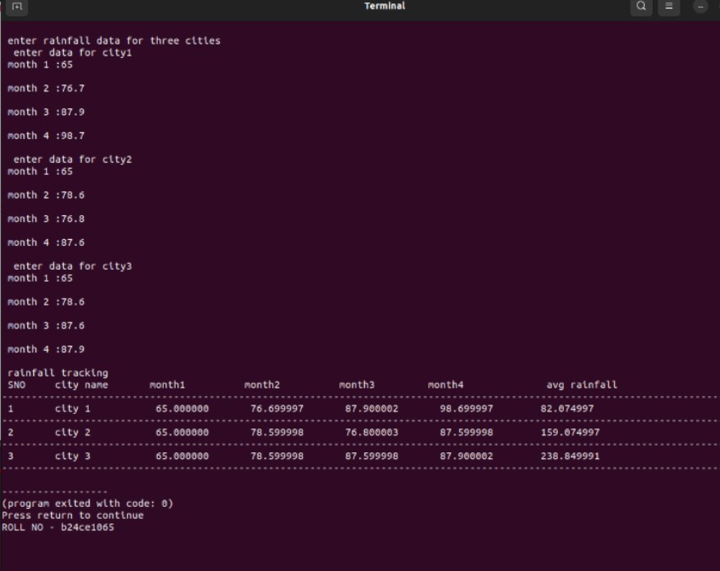

Temperature Sensor:-

#include <iostream>

using namespace std;

int main() {

float arr[3][7];

for(int i=0;i<3;i++){

cout<<"city"<<i+1<<"\n";

for(int j=0;j<7;j++){

cout<<"enter temp "<<j+1<<":";

cin>>arr[i][j];

}

cout<<"\n";

}

cout<<"Temperature Tracker B24CE1063 \n";

cout<<"cities day1 day2 day3 day4 day5 day6 day7 average \n";

for(int i=0;i<3;i++){

cout<<"----------------------------------------------------------------------------\n";

cout<<"city"<<i+1;

float avg =0;

for(int j=0;j<7;j++){

cout<<" "<<arr[i][j];

avg+=arr[i][j];

}

cout<<" "<<avg/7;

cout<<"\n";

}

return 0;

}

**OUTPUT:**

